# 15CSE386 Computer Networks Lab Online E-Voting System

**Introduction :**

In today’s world, a well known pandemic has increased due to social activities. This application targets on social activity which drastically increased the number of covid patients. Elections conducted nowadays has no control. The COVID protocols are never obeyed. This application is a online E-voting system which enable every person to vote at their respective houses and will substantially decrease the number of persons diagnosed with COVID.

# Modules Implemented in the project are as follows:

* Socket
* Tkinter
* Subprocess
* Pandas

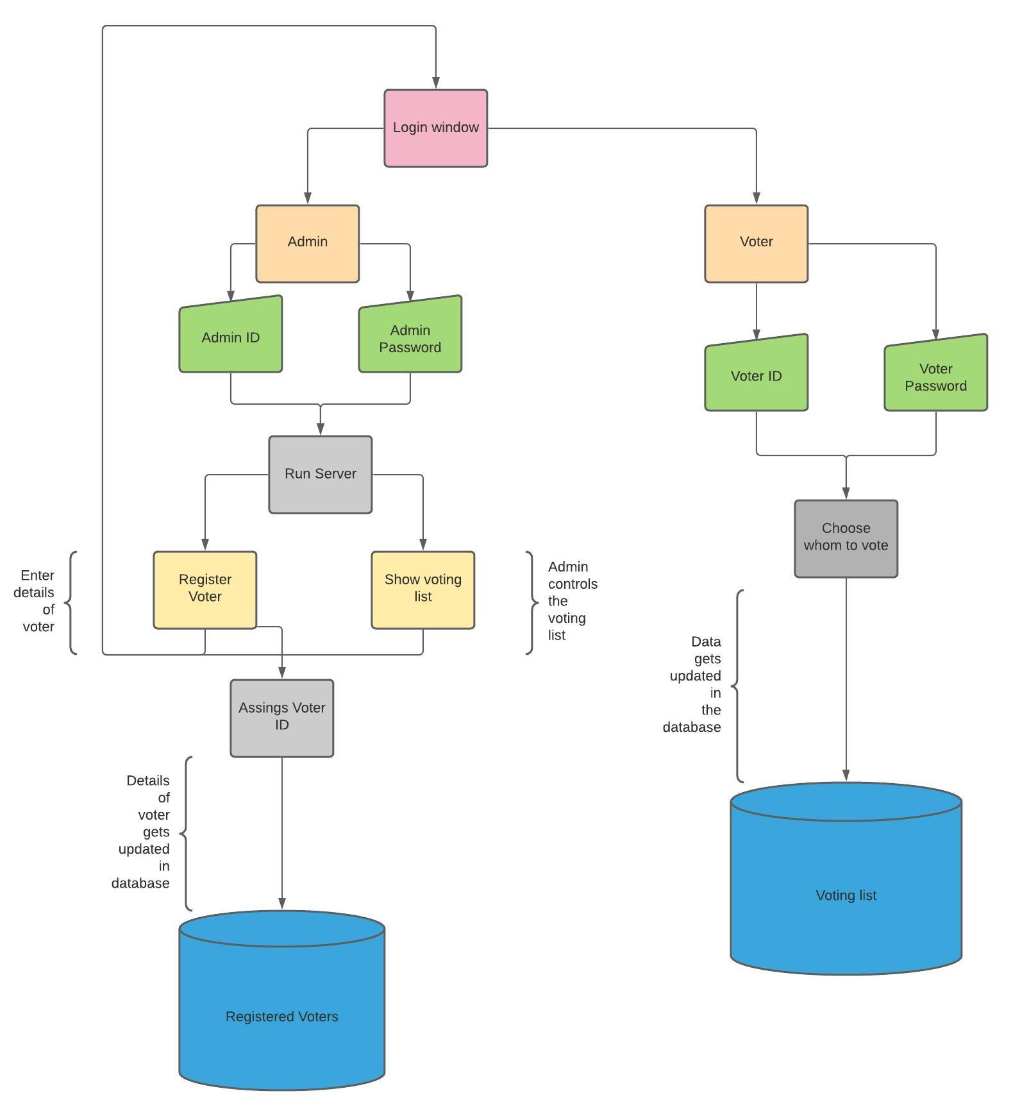

*Block Diagram for E-voting system*

# Software

Implementation of tkinter

Implementation of the database was done through CSV

# User Interface Design

The User Interface was implemented through tkinter (python module)

**Language:** python